Web Energy Logger (WEL) User Guide
(Rev 3.2 boards, Rev 2.X software)

By Phil Malone: OurCoolHouse.com
Revised: 8/29/2006

Table Of Contents:

1.0 Overview 2
2.0 Hardware 3
2.1 Power Supply 3
2.2 Rabbit CPU 3
2.3 i-Button Link 4
2.4 Watt Meter interface 4
2.5 Contact closure inputs 4
2.6 Serial communications 4
2.7 LED indicators 4
3.0 Connecting WEL sensors 6
3.1 1-Wire sensors 6
3.2 Current Switch 8
3.3 Power (Watt) meters 8
4.0 Getting Started 10
4.1 Powering up 10
4.2 Locating the WEL’s IP Address. 10
4.3 Using your browser to configure the WEL. 11
5.0 Configuring the WEL 14
5.1 Date & Time 14
5.2 Site Settings 14
5.3 Network Addresses 15
5.4 Assigning Device Names 15
5.5 Error Status 17
6.0 Owner Website Setup 18
6.1 Getting access 18
6.2 Viewing the Last Post 20
6.3 Setting the LogOrder 20
6.4 Defining Graphs (or Charts) 20
6.5 Defining your Live System Diagram. 20
6.6 Watching your data 21

1.0 Overview

The Web Energy Logger (WEL) from OurCoolHouse.com is designed to monitor and log the energy characteristics of a building. The basic WEL unit can read a large number of networked sensors (temperature & contact closure), 2 watt meters and 8 local contact closures. Filtered data is presented on a series of web pages (hosted directly on the WEL), as well as posted to the OurCoolHouse.com Website via a standard 10-baseT Ethernet connection.

OurCoolHouse.com combines the live data with graphic images to generate “system snapshots” that can be displayed on any user’s website. Live data is also stored in monthly log files and used to generate trend graphs. Logs can be downloaded by users and imported into data processing packages like Excel.

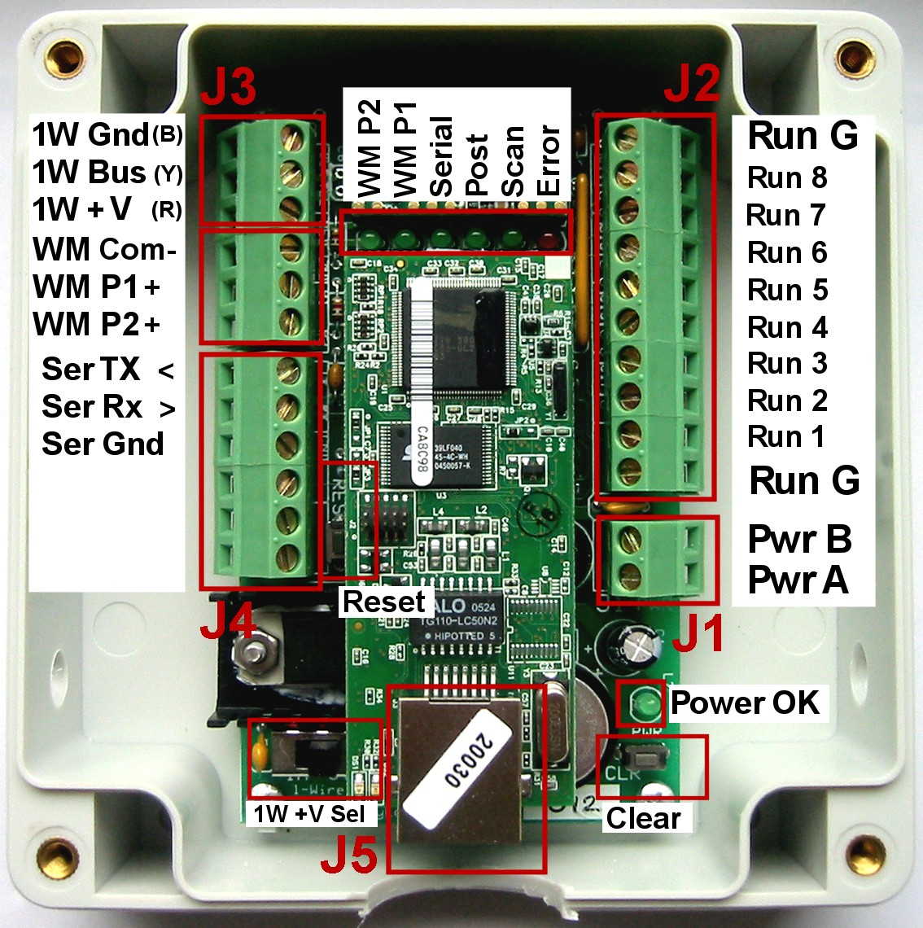

This picture shows the WEL 3.2 Unit in its preferred orientation. When the board is mounted to a wall in an enclosure, the six status LEDs should be located at the top of the board, and the Ethernet connector at the bottom. This orientation leaves the top surface of the enclosure free from holes. The version of the WEL is marked on the main circuit board, directly under the LAN connector. A WEL 3.2 board can also be identifiable by the “1-Wire +V supply” switch located near the regulator heat sink.

2.0 Hardware

The WEL comprises several hardware elements. These are described below.

2.1 Power Supply

The WEL uses a simple analog voltage-regulator to generate the required +5V. Unregulated raw voltage is applied to the board though the J1 terminals (PRW 1 and PWR 2). These terminals are separated from the other terminals to make identification easy.

The raw input voltage can be AC or DC, and should be in the 9V to 12V range. A higher voltage can be used (up to 24V), but this may cause the regulator to overheat. A full-wave bridge-rectifier is used on the PWR Inputs so input polarity doesn’t matter (ie: the two power wires can be connected either way around). As soon as power is applied, the LED next to the regulator will illuminate to indicate that +5V is being generated.

An inline reset-able poly-fuse is used to limit input current draw (in the event of a component failure). This fuse trips at about 1A.

The WEL can provide two different voltages to the 1W +V line to power custom circuits. A slide switch is provided on the board (next to the regulator heat sink) to select between the rectified input voltage, or the Regulated +5V. Put the switch in the “+5V” position if any custom circuits require +5V. Otherwise, if the custom circuits have their own on-board regulators, put the switch in the “Input” position.

An inline reset-able poly-fuse is also used on the 1W +V line. Current is limited to 0.75A

2.2 Rabbit CPU

A compact CPU core from Rabbit Semiconductor is used to perform all the WEL’s software functions. This RMC3700 module contains CPU, RTC, RAM, FLASH and Ethernet Interface. The Ethernet Interface is a RJ-45 connector identified as J5 on the image above.

On power-up, the RCM3700 starts the program and initialized all the onboard systems. The program then scans all the system sensors, and posts data as required. The program also starts the local Web Server that is used to perform WEL configuration.

Each WEL is shipped with a standard Network configuration default.

IP address is: 0.0.0.0
Network Mask: 255.255.254.0
Gateway: 192.168.1.1
Name Server: 192.168.1.1

The 0.0.0.0 IP address causes the WEL to obtain a dynamic IP assignment from the network Host. The LocateIP can be used to determine the IP address assigned to the WEL. A predefined Fixed IP can be requested when ordering the WEL, or configured using the LocateIP program. See section 4.2 for more details.

2.3 i-Button Link

A robust 1-wire interface from ibuttonlink.com is used to drive the 1-wire sensor network. This interface supports mixed network topologies (bus/star/branch) and the “Strong Pull-Up” function required for parasitically powered devices.

The 1-Wire signals are available on J3. Although only 2 signals are required for 1-Wire operation (1W Gnd and 1W Bus), a third line is provided to power optional remote devices (1W +V).

The software is able to detect a broken or shorted 1-Wire bus, and these conditions are displayed on the Error LED, which will flash an error code if there is a problem.

2.4 Watt Meter interface

The WEL can connect to two Wattmeter pulse outputs. Although the interface is designed for Watt Meters from Continental Control Systems, any wattmeter with optically isolated, or dry contact outputs will work. A 1K-Ohm pull-up is used to sense contact closure. To signal a “pulse” the wattmeter must short it’s pulse input (WM P1+ or WM P2+) to the common ground (WM Com-) found on the J3 terminals.

2.5 Contact closure inputs

The WEL is able to sense up to 8 contact closures, and report these as unique sensor inputs. These will typically be used to detect pump-run or motor-run conditions. Run inputs are presented on the J2 terminals. To signal a “run” condition, an input (Run 1 – Run 8) must be shorted to either of the Run Gnd inputs.

2.6 Serial communications

WEL will be able to support additional Serial Communications in the form of two RS-323 ports or one RS-422 port. These signals will be accessed via the J4 Terminals. This is a future software function. These are currently not used.

2.7 LED indicators

The WEL has 9 LED status indicators. Two of these are located on the CPU/LAN module, and the remaining seven are on the main WEL carrier board.

The LAN indicators are:

Network on: LED on the RMC3700 module next to the cable jack.
Lights solid Green when an active network cable is attached.
Network talk: LED on the RMC3700 module next to the cable jack.
Flashes Red when data is being sent/received by WEL.

A single Power On indicator is located next to the power input terminal. The remaining six indicators are located in a row between the RCM3700 module and the iButton Link module. With the board oriented with the Internet jack at the bottom, the LED functions from left to right are:

Watt P2: Changes state each Power Pulse on PWR 2 input.
The more power being consumed, the faster this LED flashes.
Watt P1: Changes state each Power Pulse on PWR 1 input.
The more power being consumed, the faster this LED flashes.
Serial Log: Flashes if/when serial data log is sent out com port.
Web Post: Turns on while transmitting data to external website.
Default update rate, once per minute.
Bus Scan: Turns on while 1-Wire bus is being scanned.
Should light for one second every six seconds.
Error: If an error occurs, this LED flashes the error code.
One short flash (1/4 sec) for each Unit of the error code,
One long flash (1 sec) for each Ten of the error code,
Pattern repeats as long as there is an error.
Eg: Error 12: One long flash, two short flashes.

Error codes:
1 1-Wire interface failed
2 No 1-wire devices found
3 Short circuit on 1-wire bus
10 Generic network error
11 DNS Server not found
12 Web Post timed out
13 Failed to synch to external time
20 Generic program error
21 Too Many 1-Wire devices

3.0 Connecting WEL sensors

3.1 1-Wire sensors

The WEL utilizes the innovative 1-Wire network developed by Dallas/Maxim. This network enables a large number of sensors to be attached to a single twisted pair network. The term “1-Wire“ is somewhat erroneous since the network actually utilizes 2 wires, but since one of these is a simple ground wire, the other “1-wire” supplies both power and communications.

All 1-Wire devices have a unique 64-bit “address” that is used to differentiate the various sensors on the bus. Since this address is cumbersome to use, the WEL provides a means for assigning more “meaningful” names (up to 16 characters) to each sensor (eg: T1, T2, P2). Since all the sensors are physically identical, names are assigned by adding sensors to the net one at a time. As each sensor is added, it shows up as an un-named device that can then be named. Address-Name pairs are stored on the WEL in Flash memory, so once a name is assigned it “sticks” to that device.

The most predictable way to hook up your 1-Wire sensor array is to take one long twisted cable and run it from the WEL, past all the sensors. This is what I provide in the basic WEL Starter Kit. In this case the 1-Wire bus is a 40’ twisted triad (three wires) with the default WEL color code (Black=Ground, Yellow = Signal, Red = +V). The third wire (Red) is provided to power more sophisticated 1-wire sensors. These sensors require +V supply current, that can’t be supplied by the normal 1-wire bus. The WEL is able to provide regulated +5V or unregulated +9V on this third wire.

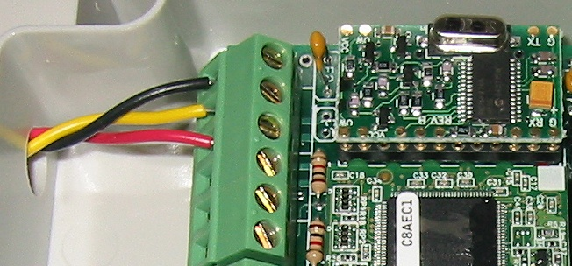
Here you see the Bus cable connected to the WEL using this color code.

Then to attach a temperature sensor, you just need to wire it to the bus at the desired location. I like to use an attachment device called a Tap-Splice. This gadget lets me crimp the sensor wires to the bus without any cutting, stripping or soldering. A Tap-Splice is clipped onto one bus wire, and the corresponding colored Sensor wire is inserted into the splice. The assembly is then squeezed using a large pair of pliers and the connection is made. The operation is repeated for the other wire.

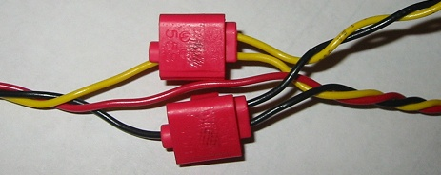
Here is a picture of a finished splice pair. The bus is running along the bottom of the image, and the attached sensor wires are leaving at the upper right. Notice that nothing is happening to the red wire. Each of my Ready-To-Install sensors comes with two Tap Splices.

These splices are somewhat big because they are designed to handle lots of power. We don’t need that, but they do a good job anyway.

In some situations, it’s just not convenient to have one single long bus for all the sensors. In these cases, one incoming pair might need to branch out to several sensors throughout the house (eg: at thermostat locations). Here, the various pairs are connected in “parallel” to form a “Star” network. You should attempt to limit the number of stars in your system by deciding on a central hub location and only fanning out from there.

Technical note: If you don’t want to use my ready-to-install sensors, you can “roll your own” using raw temperature sensors from Maxim/Dallas. Currently two different temperature sensor types are supported by the WEL. These are the DS18S20 and DS18B20 precision temperature sensor families. Additional types will be added in the future.

The most minimal configuration for a 1-Wire device is the “parasitic power” mode, where the device “steals” power from the data line. This is what I use for my Ready-To-Install sensors. In this mode, the device’s VDD pin must be tied to the GND line for noise immunity. Special versions on the DS18S20 and DS18B20 devices are sold where this connection is made inside the device, thus eliminating any need for external wiring. The “–PAR” suffix is added to the part number to indicate this feature.

In some situations, a 1-Wire sensor needs more power than is available via the data line, and in these cases, the VDD pin must be attached to a separate +V line. For this reason, the WEL provides a suitable line (1Wire +V) as part of the J3 Terminal group.

Here are some sample device pin-outs.
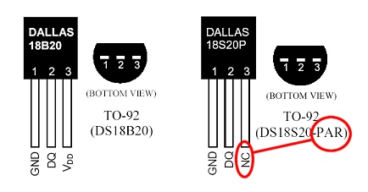
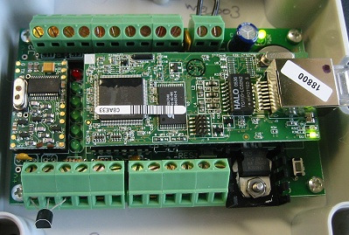
Here the WEL is shown in a minimal “no-errors” configuration. The unit has power, a LAN connection and a single DS18B20 temperature sensor wired across its 1-Wire terminals.

Notice that the curved side of the sensor is facing out (up).

This is just a simple (goofy) way to get instant gratification with the WEL.

3.2 Current Switch

The Current Switch (CS) from CR Magnetics is another popular sensor for the WEL.

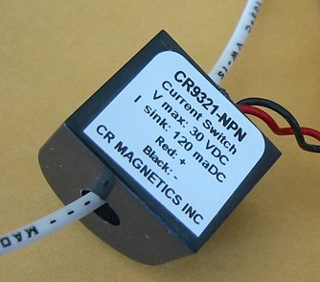
As it’s name implies, the CS is a switch that turns on when it senses current. This is a great way to detect when a device like a pump or heater element is on.

The beauty of this kind of sensor is that there is no electrical connection with the actual device being monitored, so it’s very safe. One of the power conductors of the device being monitored is passed through the hole in the CS. When more than 350ma of AC current is detected in this wire, the CS closes an optical output, which can be detected any of the 8 run-monitor inputs on the WEL.

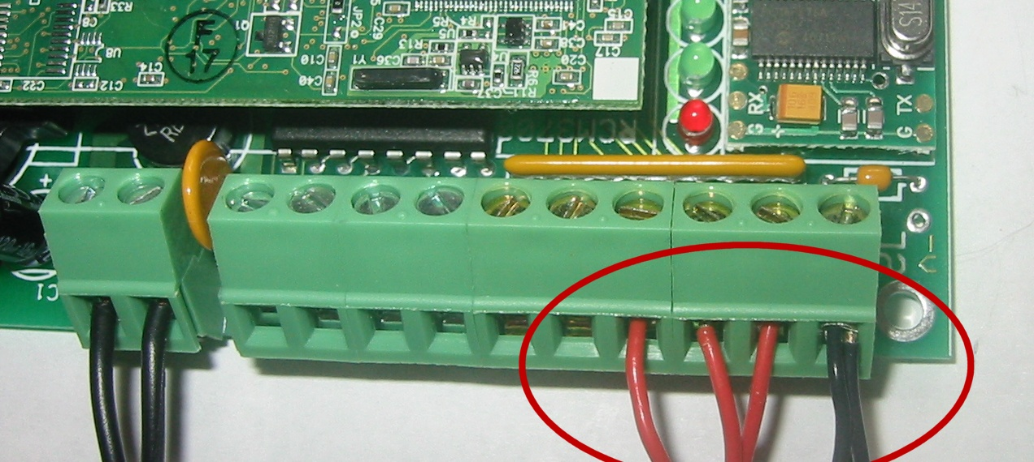
Each CS has two output wires. The black (-) wire is a common ground that is connected to either of the run-monitor COM inputs on either end of the terminal strip on the WEL. The red wire (+) is the actual signal wire, and each of these is connected to a single run monitor input (1-8).

This photo shows 3 CS’s connected to the WEL as run inputs 6,7 & 8.

If it’s not convenient to wire a CS directly to the WEL, or if you need to monitor more than 8 devices, I have developed a 1-wire interface for the Current Switch. This interface is wired to the CS, and provides the standard Black/Yellow wire pair that can then be connected anywhere on the 1-wire bus. This configuration can provide the ultimate in wiring convenience and flexibility. I call this my “1-wire Current Switch” (p/n WEL-CS)

3.3 Power (Watt) meters

The WEL has two power inputs which can count pulses indicating power consumption.

Although the WEL can work with most pulse-output meters, only one brand provides the high frequency outputs that enable me to calculate an accurate instantaneous “load”. These units come from Continental Control Systems (http://www.ccontrolsys.com) and they are called Pulse-Output WattNodes. The WEL requires a specific high frequency version of the WattNode: the WNA-1P-240-P193 (for split phase 110/220V measurement) or the WNA-3D-240-P193 (for single phase 220V measurement).

Note: The –P193 suffix is essential to get the high-frequency version of the unit. Without this, you will not be able to measure load in watts.

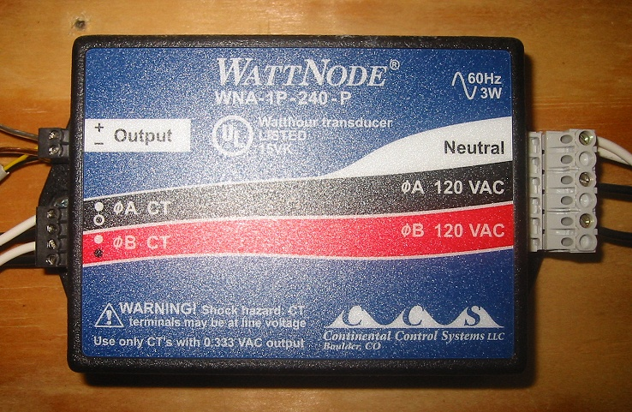

Like the current switches, the WattNode also has an optical output that is wired directly to the WEL. The (-) output is wired to the common ground input and the (+) output is wired to either the PLS1 or PLS2 input terminals on the WEL.

Technical note: Below is a wiring diagram that shows several sensors and two WattNodes connected to the WEL

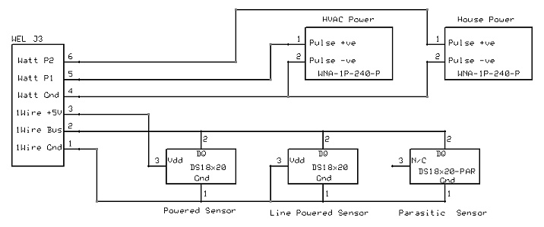

4.0 Getting Started

The easiest way to get started is to connect the WEL to an active Local Area Network, and apply power. You can do this by plugging the WEL into a hub or router in your home or office, and then connecting a WEL power supply.

Note: It is possible to plug the WEL directly into your computer’s network card, but you will need a special “Crossover” cable to do this.

4.1 Powering up

When power is applied, the WEL will boot up and load it’s operating program from FLASH memory. The 6 status LEDs give a very characteristic “ramp” display to signal the start of booting. All the LEDs light up in sequence, starting with the first green LED and working over to the RED led. This takes about a second. Then the LEDs stay lit for about ten seconds, at which point they all flash once and enter the normal running state.

At this point the WEL is ready to post data or accept configuration requests.
After about 6 seconds, the Green LED near the Network Connector should go on, and stay on. This indicates that the WEL has successfully activated the TCPIP network. (You remembered to plug the cable in, right?)
Since you have not attached a 1-wire network, the system should detect a “No Devices” condition and report error number 2. This will cause the “Error LED” to flash a repeating pattern of two short flashes.

To view and update the internal workings of the WEL, you must now configure a PC on the same LAN to be able to access the WEL’s local web server.

4.2 Locating the WEL’s IP Address.

The WEL is an Internet appliance. To communicate with other devices it needs an Internet Protocol Address (or IP Address). You need to know the WEL’s IP address so that you can configure it using your PC’s Internet browser.

IP Addresses are represented by a series of 4 numbers separated by periods. Each number is between 0 and 255. The WEL’s favorite IP Address is 192.168.1.50 . This address can operate with most broadband routers, but it’s not foolproof.

Devices like the WEL, can be given a “Fixed” IP or they can obtain them “Dynamically”. If you’re a net weenie, you’ll probably want to assign your WEL a fixed IP, because you can, and it makes it easy to remember. If you’re a net novice, you’ll probably want your WEL to get it’s own IP thereby eliminating the need for you to assign one.

Unless you request a specific IP when you order your WEL, it will come set-up to obtain a dynamic IP. So, once it’s up and running you will need to search it out and determine it’s IP address so you can “talk” to it. You will use a program called LocateIP.exe to do this. You can download this program from the WEL Support Files page of the support website:

http://www.webenergylogger.com/WEL/support.htm

Load the program onto your PC and run it. It will immediately search for the WEL and once it finds it, will display its network parameters, including its IP address. See below.

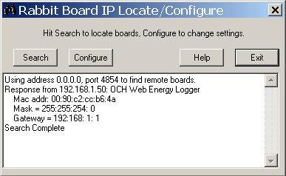

In the example, you can see that the program got a “Response from 192.168.1.50”. This is the WEL’s IP address. You’ll also not that the Gateway address is 192.168.1.1, this is typical for most network routers (like Linksys). If need be, these addresses can be changed by clicking the “Configure” button and entering the desired addresses.

If you run LocateIP and it doesn’t find your WEL, it’s probably because your PC’s firewall is preventing the WEL’s response from getting back to your PC. Try turning off your Firewall temporarily. Then turn it back on again once you have the WEL’s IP.

4.3 Using your browser to configure the WEL.

Once you know your WEL’s IP Address, you can use any Web Browser to configure it.

Start your Web Browser on the same computer that you ran the LocateIP program on. Enter the WEL’s IP address in the location that you would normally type a Web Page’s name. In this example, the address would be entered as: http://192.168.1.50:5150

Note that the address starts with “http://” and ends with “:5150”
This connection is not being made to the standard Port 80, it is using Port 5150 to enable remote access via a network router.

The Web browser should now display the WEL’s Home page, shown below.

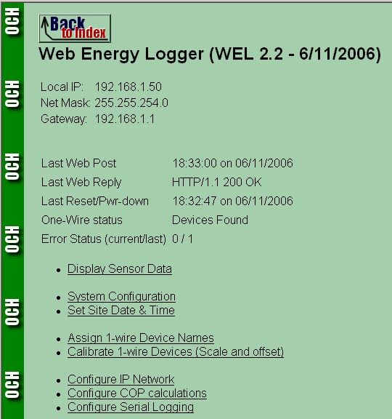

The WEL home page shows some key system information (Network addresses and Error status) and also provides a list of other available setup functions.

Display Sensor Data:
View the latest readings for all the attached sensors.

System Configuration:
Set your WEL’s self-identification information (WEL ID, password etc).

Set Date/Time:
Set the WEL’s real time clock.

Assign 1-W Device names:
Map the individual sensors by giving them short identifiers (names like T1, T2 etc.). These names are used when configuring online displays and data logging.

Calibrate 1-W devices:
Set the scale and offset for converting sensor values into real-works units.
The system will assign default values, but you may tweak them for your specific hardware.

Configure Network:
Override the default network IP addresses.

Configure COP Calculations:
Designate specific inputs to be used for calculating Coefficient of Performance.

Configure Serial Logging:
Designate which sensors to log, and what serial parameters to use.

Each of these functions is described in the following section.

5.0 Configuring the WEL

The first time you configure your WEL, you’ll want to do a few basic things.

5.1 Date & Time

Use the Set Date/Time link to set the real time clock. Remember to enter the time in 24-hour format. Use the Back To Index button to return to the main page. I ignore daylight savings time when setting the clock to provide a more consistent sensor log.

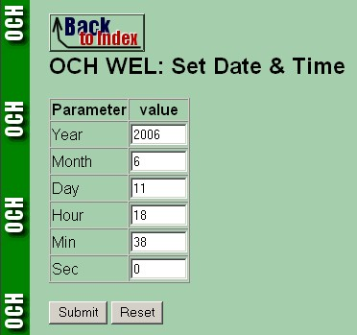

5.2 Site Settings

Next, use the Configure Site link to verify your WEL settings. These should have been set for you, prior to shipping, but it pays to check them. Make sure the WEL has the correct Site ID and password. A sample configuration is shown below.

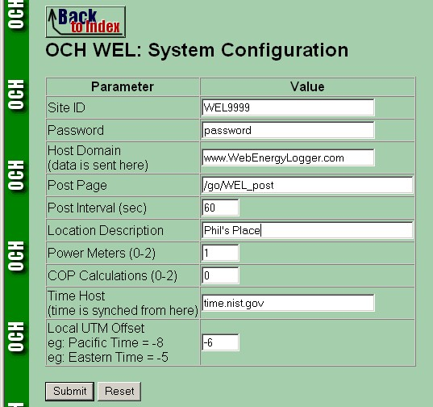

5.3 Network Addresses

The next thing to check is the network setting. Use the Configure Network link on the main page. Here you can set the Board’s IP and Net-Mask. To get access to the Internet, you also need to set the Gateway IP. This could be your Cable modem, Network Router or Internet Sharing PC. The default for this is 192.168.1.1, which is a common router setting. Finally you may need to enter the IP of your ISP’s Domain Name Server (DNS).

If you change any of these settings and hit submit, the WEL will reset itself to load the new settings. Don’t forget to change your Web Browser address if you change the WEL’s IP.

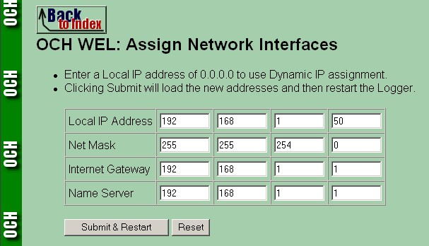

5.4 Assigning Device Names

The final step is to “Name” any sensors that are attached to the WEL. This is done using the Assign 1-Wire device names link on the main page.

Each time the WEL is reset it scans the 1-Wire bus for sensors. It then looks up their unique addresses to see if they have assigned “names”. It’s your job to make sure that all the sensors have names so they can be posted to the logging website. See the sample screen below.

Every sensor device that the WEL can read has a pre-defined “Address”. If that device is a 1-wire senor, the address will be a 16 character HEX number. This is the device’s factory assigned address. All otherwise devices or sensors will have an address assigned by the WEL itself. Several examples of these are shown below. There are 8 run sensors on the WELL that have pre-assigned addresses of R1 to R8. There is also one Wattmeter input configured in this example, and it has three addresses: M1Load, M1Day, M1Month. These correspond to the current load in Watts, the daily power consumption in KWH and the Monthly power consumption in KWH.

The third column is the “Logical” name associated with each sensor value. This is the name that YOU set based on what that sensor’s reading. It pays to keep these names as short as possible.

The final column is used to indicate whether you want the system to maintain accumulated hour values for a given sensor. The default of A ‘N’ indicates that NO accumulation is required. ‘D’ and ‘M’ indicate a Daily or Monthly accumulation, and ‘B’ indicates that both accumulations are desired. Accumulations work by taking the sensor value and multiplying it by the amount of time it is on (in hours). For a digital on/off sensor, this leads to a “Run Time” value in hours. Note the example below for GSHP, Fan and Heater (all set to B).

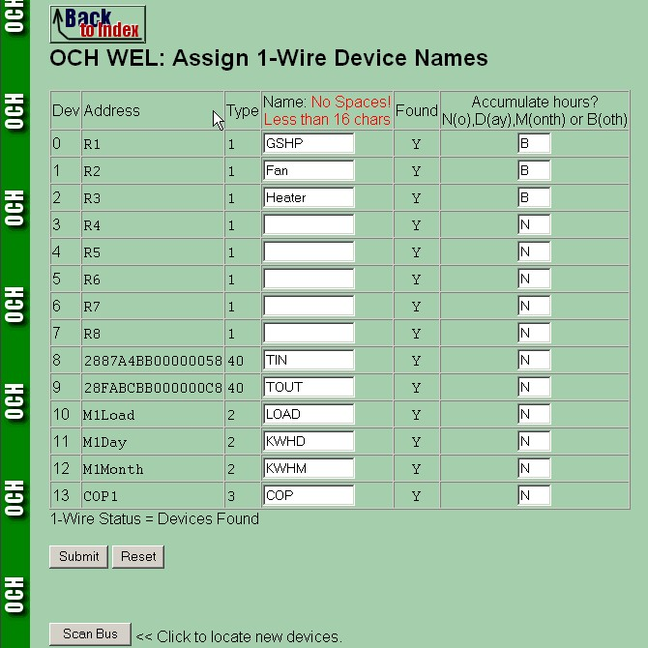

Here, in addition to the value for GSHP being posted to the website, the WEL will also post a value for GSHP_D (the daily hour total) and GSHP_M (the monthly hour total).
If new sensors are added to the 1-Wire bus while the system is running, use the “Scan Bus” button to direct the WEL to search out the new device, and add it to the sensor list. The best way to add 1-wire sensors is to connect them one at a time. As each sensor is added, scan the bus to determine its address, and then assign it a name using this page.

5.5 Error Status

Before continuing on to the next stage, you should return to the WEL home page and check the error status. Two numbers are displayed. The first number is the current error state, and the second number is the prior error state. If you have at least one 1-Wire sensor installed and the WEL has access to the Internet then the error status should be 0 (no errors). Look up any error number in section 2.7 to determine its meaning:

Typical errors are:

2 No 1-Wire sensors are detected (check connections)
3 Short on the 1-Wire bus, or a sensor is connected in reverse.
10 Could not attach to an active network (check cable)
11 Could not locate the DNS Server (verify DNS setting)
12 Could not connect to the post web site (verify Gateway setting)

Within a minute of starting up the WEL, the first Web post should occur which will result in a Last Web Reply result of “HTTP/1.1 200 OK” being displayed on the WEL home page (do a refresh to get the latest status). Any other status indicated a potential problem with your Internet connection or ISP.

Once you get the 200 OK message, it’s time to do your “Happy Dance” and get ready to start generating cool online images and charts. Read the Owner Setup section for details of how to configure on-line charting.

6.0 Owner Website Setup

It’s more fun to set up your Web Logging page when you have real data coming from your WEL, but if you don’t have your WEL yet, you can still get ready by defining your expected data and desired display.

In section 5, we were dealing with web pages that exist on the WEL board itself. However, all of the Web Pages described in this section relate to the Online Owner Setup pages that exist out on the World Wide Web. This is where you WEL posts its data, and this is where the cool graphics are generated and where the sensor data logs reside.

6.1 Getting access

There are three main Owner Setup activities, and they are all managed from your password protected Owner Setup page, which is located at:

http://www.OurCoolHouse.com/WEL/admin/WEL

There is also a convenient link on the www.OurCoolHouse.com/WEL page.

To access your setup page, you will be asked for a User Name and Password. You must enter your WEL’s Site ID and password. These are the same items that appear on your WEL’s Configure Site page. You will also receive these from Phil when he ships your WEL unit. If you don’t have this information, call or email Phil.
Phone: (301) 387-2331, webmaster@ourcoolhouse.com

Once you reach the Owner Setup page, add it to your browser Favorites. You’ll be back here often.

The Owner Setup home page provides a quick snapshot of your current configuration. It shows the last post that was received from your WEL, how you want your data logged, what you want displayed on your “System Image” and what graphs you want to be generated. It also contains links to other pages where you actually edit these various settings. A sample Owner Setup page is shown below:

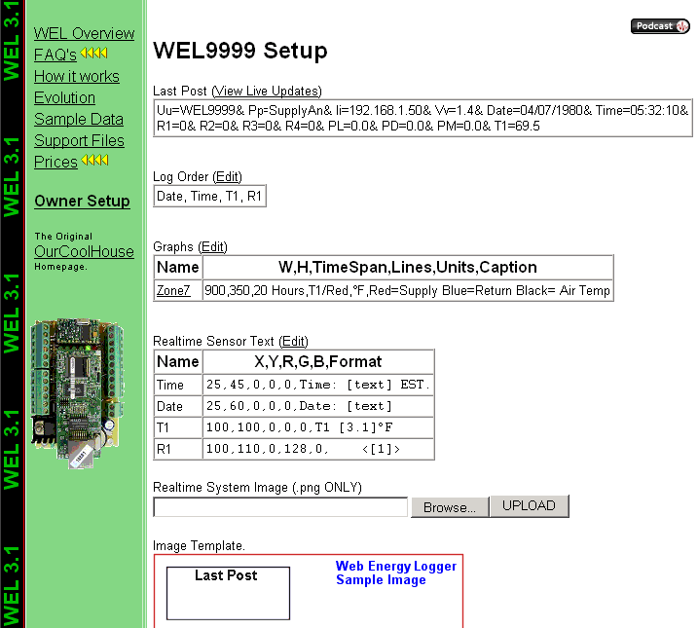

Notice that each section has a link called “Edit”. Click this link to change the information in the adjacent table. You will be taken to a new page with one or more text entry fields.

Note: This next sentence is probably totally wasted on people just like me, but I’ll try it anyway.

If you have a question about what to enter on any particular page, scroll down and READ the Tips at the bottom of the page. I hate typing, so if I’ve gone to the trouble of including a tip, then there must be a really good reason. Trust me… I can read your mind. Plus if I need to add more help info. I’ll do it there, rather than in this document. So don’t say I didn’t tell you ☺

6.2 Viewing the Last Post

The first box at the top of the screen shows the last data that was posted by the WEL. This is useful during debugging to ensure that you are getting data (check the date & time sections) and to verify the names of posted sensors.

The View Live Updates link will take you to a page that shows all your generated images. These will automatically update each time you get a WEL data post. This is another good page to bookmark as it’s not password protected so you can send the URL to your friends, or just use it to check your WEL.

6.3 Setting the LogOrder

The first thing you need to do is define which sensors will be logged, and in what order.

THIS IS CRITICAL. IF A SENSOR IS NOT LISTED IN THE LOGORDER,
IT WIL NOT SHOW UP IN ANY IMAGE OR CHART.
This is a good time to sit down and give names to all the sensors you intend to have attached to the WEL. Start a document or spreadsheet to keep track of the names and functions. These names MUST match the names you define on the WEL, but don’t worry if you haven’t installed them yet. Just give them a name and add them to the LogOrder.

Each time the WEL posts data, the values of the sensors in the LogOrder are added to your downloadable Log File. They are stored in tabbed columns that can be imported into Excel. Choose a log order that will make it easy to view and analyze your data. Missing sensors are logged as Question marks, to keep the columns intact.

So, click the Edit link above the LogOrder Box. Follow the instructions and then return back to this page. Did I mention that you should read the tips?

Note: The LogOrder Edit page also contains a link to your actual Log file, so go there to download it.

6.4 Defining Graphs (or Charts)

The second best thing you can do with WEL data is build graphs. You can have up to 8 graphs, each with up to 8 sensors on them. Graphs are great for plotting Zone Air or Water temperatures or GSHP power usage or whatever. If you really want to see how something is working… then graphs it.

Graphs can show short or long trends, from hours to weeks. You get to set the size and duration of the chart just by entering some simple information. Click on the Edit link above the Graphs box to start defining graphs. Er… don’t forget to read the tips….

6.5 Defining your Live System Diagram.

OK, this is the BEST thing you can do with WEL data. This is where you get to pull all the WEL data together on one cool system diagram that automatically gets updated with sensor values.

It all starts with you creating a “Template” image. Take your favorite image creation program (paintshop, photoshop, visio, whatever) and draw a diagram of the system you are monitoring. Don’t go crazy right off the bat making it too big, or too complicated. Start out with a size that’s easily viewable on most computers. I’d recommend making it less than 800 pixels wide and 600 pixels tall. In fact, 640x480 is a great size. Then decide how you want to depict your system so that you can easily add numeric sensor values. Here’s some example links of images WITH their sensor values:

http://www.ourcoolhouse.com/monitor/OCH01.png << 640 x 480

http://www.ourcoolhouse.com/WEL/WEL0003/system.png << 815 x 665

Your goal is to create an image without the sensor values, upload it to your Owner Setup page, and then tell the page where you want the sensor values put. You’ll need to create an image using the .PNG format (like .gif) and then upload it using the “Realtime System Image” Upload button on the Setup page.

Once you’ve uploaded the image, it will appear at the bottom of the page in its “raw” form.

After uploading the image, you then use the “Realtime Sensor Text” Edit link to start adding values to the image. Any sensor value being posted by your WEL can be added to the image, including the post date and time.

The Tips on this edit page are EXTREMELY important so make sure you read them to get the most out of your image.

Date and Time are always the best to start with, and the default Owner Setup page has these already. Just change the position to suite your graphic.
Remember, the System diagram is only updated one a minute, so allow enough time between changes to see your results. Watch the "time" on your image change to tell if the image should have been updated.

6.6 Watching your data

Remember that there is a public web page that includes your system image and all your charts. It’s address is based on your Site ID. The URL format is:

http://www.ourcoolhouse.com/WEL/WELXXXX

Where XXXX is your Site ID. While making changes to your setup, you may want to keep this page open in a new window to see the results of your settings.

