Web Energy Logger (WEL) User Guide
(Rev 3.3 boards, Rev 2.13 software)

By Phil Malone: OurCoolHouse.com
Revised: 12/19/2007

Table Of Contents:

1.0 Overview 2
2.0 Hardware 3
2.1 Power Supply 3
2.2 Rabbit CPU 3
2.3 i-Button Link 4
2.4 Pulse/Counter (Flow/Watt Meter) interface 4
2.5 Contact closure inputs 4
2.6 Serial communications 4
2.7 LED indicators 4
3.0 Connecting WEL sensors 6
3.1 1-Wire sensors 6
3.2 Current Switch 7
3.3 Power (Watt) meters 8
4.0 Getting Started 9
4.1 Powering up 9
4.2 Locating the WEL’s IP Address. 9
4.3 Using your browser to configure the WEL. 10
5.0 WEL Configuration pages 12
5.1 Display Live Data 12
5.2 Set Device Names and Accumulations. 13
5.3 Calibrate Devices (Scale and Offset) 14
5.4 Define/Edit Expressions. 15
5.5 System Configuration 17
5.6 Configure IP Addresses 18
5.7 Configure Serial Logging. 18
5.8 Set Date and Time 19
5.9 Delete unused devices 20
5.10 Soft Boot the WEL 21
6.0 Owner Website Setup 22
6.1 Getting access 22
6.2 Local and remote IPs. 22
6.3 Viewing the Last Post 23
6.4 Setting the LogOrder 23
6.5 Defining Graphs (or Charts) 24
6.6 Defining your Live System Diagram. 24
6.7 Watching your data 26
Appendix A: Device Type codes 27
Appendix B: Compatible Third Party 1-Wire devices 28
Appendix C: Temperature Measurement tips 29

1.0 Overview

The Web Energy Logger (WEL) from OurCoolHouse.com is designed to monitor and log the energy characteristics of a building. The basic WEL unit can read a large number of networked sensors (temperature & contact closure), 4 pulse-output devices (watt-meter or flow meter) and 8 local contact closures. Filtered data is presented on a series of web pages (hosted directly on the WEL), as well as posted to the WELServer.com Website via a standard 10-baseT Ethernet connection.

WELServer.com combines the live data with graphic images to generate “system snapshots” that can be displayed on any user’s website. Live data is also stored in monthly log files and used to generate trend graphs. Logs can be downloaded by users and imported into data processing packages like Excel.

This manual describes WEL units that use the Rev 3.3 circuit board and Rev 2.13 (or higher) WEL software. For earlier versions of the board or software, go to the “legacy” section of the WELSever.com support files page, and download the Rev2.2 User Manual.

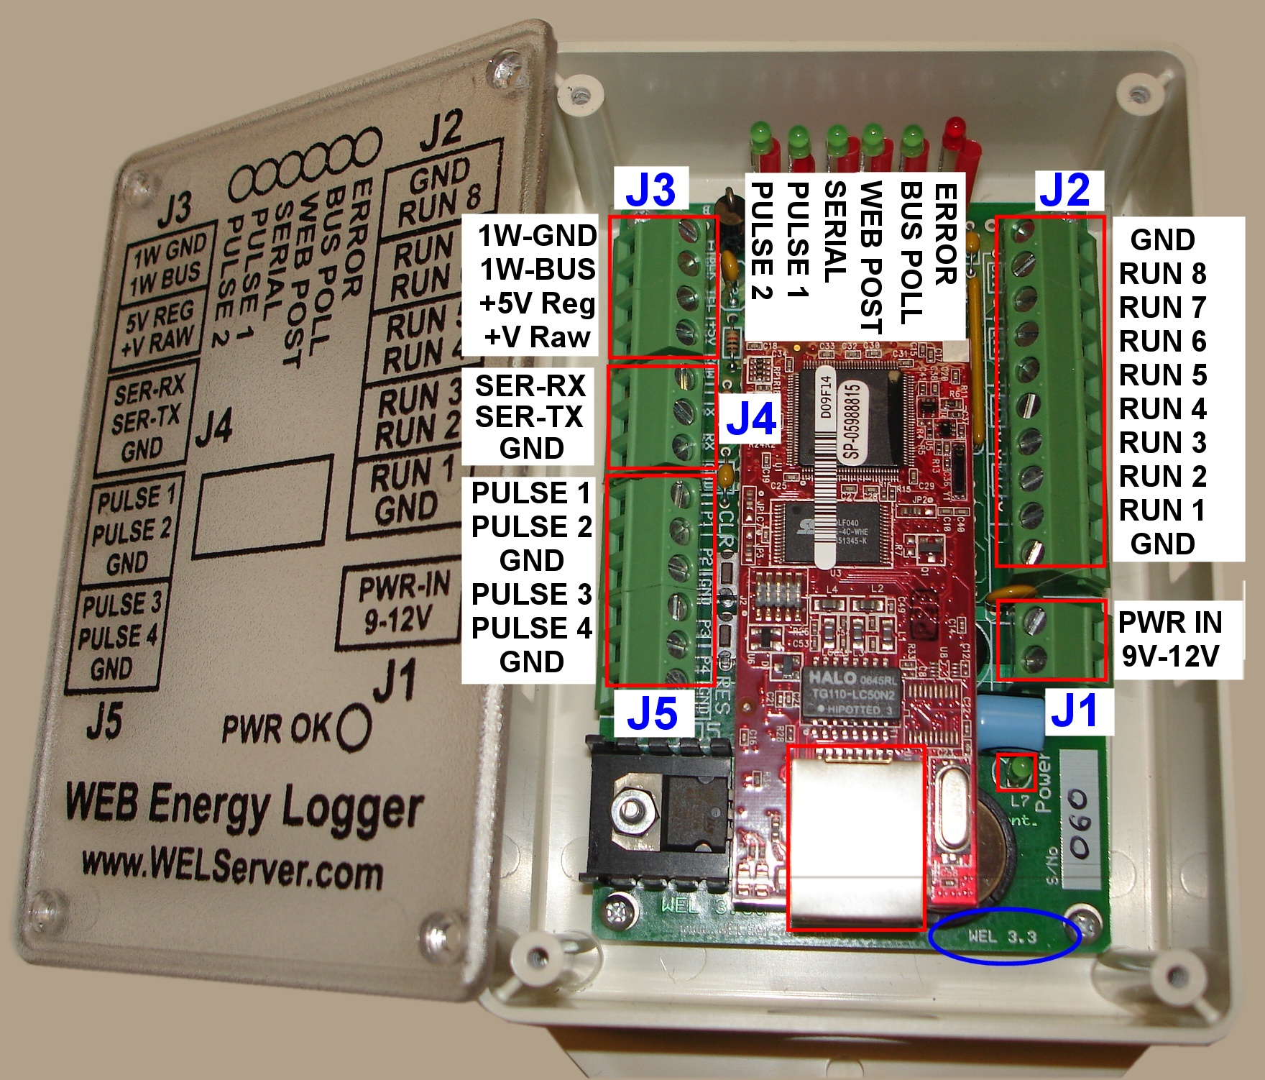

The previous picture shows the WEL 3.3 Unit in its preferred orientation. When the board is mounted to a wall in an enclosure, the six status LEDs should be located at the top of the board, and the Ethernet connector at the bottom. This orientation leaves the top surface of the enclosure free from holes. The version of the WEL is marked on the main circuit board, directly under the LAN connector. A WEL 3.3 board can also be identifiable by the stand-alone 4 terminal 1-Wire bus connector.

2.0 Hardware

The WEL comprises several hardware elements. These are described below.

2.1 Power Supply

The WEL uses a simple analog voltage-regulator to generate the required +5V. Unregulated raw voltage is applied to the board though the J1 terminals. These terminals are separated from the other terminals to make identification easy.

The raw input voltage can be AC or DC, and should be in the 9V to 12V range. A higher voltage can be used (up to 24V), but this may cause the regulator to overheat. A full-wave bridge-rectifier is used on the PWR Inputs so input polarity doesn’t matter (ie: the two power wires can be connected either way around). As soon as power is applied, the LED next to the power input will illuminate to indicate that +5V is being generated.

An inline reset-able poly-fuse is used to limit input current draw (in the event of a component failure). This fuse trips at about 1A.

The WEL provides two different voltages to the 1W bus to power custom circuits. These voltages come from two points on the WEL’s own power supply. The Raw DC supply comes from the input side of the 5V regulator, and the +5V is from the output side. Either or both of these voltages can be sent along with the 1-Wire bus since both voltages are made available on J3. Each supply line has an inline reset-able fuse to limit excessive current that might prevent the WEL from running.

Note: The bus wire sold by OurCoolHouse.com only has 3 conductors, so the user must choose whether to send the raw or regulated supply. If you want access to both supplies, a total of 4 conductors will be required (Gnd, Data, +5 DC and Raw DC)

2.2 Rabbit CPU

A compact CPU core from Rabbit Semiconductor is used to perform all the WEL’s software functions. This RMC3700 module contains CPU, RTC, RAM, FLASH and Ethernet Interface. The Ethernet Interface is a RJ-45 connector identified at the bottom of the enclosure.

On power-up, the RCM3700 boots from the flash file system. The program starts and initializes all the onboard systems. The program then scans all the system sensors, and posts data as required. The program also starts the local Web Server that is used to perform WEL configuration.

Each WEL is shipped with a standard Network configuration default.

IP address is: 0.0.0.0
Network Mask: 255.255.254.0
Gateway: 192.168.1.1
Name Server: 192.168.1.1

The 0.0.0.0 IP address causes the WEL to obtain a dynamic IP assignment from the network Host. The LocateIP.exe program can be run from a networked computer to determine the IP address assigned to the WEL. A predefined Fixed IP can be requested when ordering the WEL, or configured using the LocateIP program. See section 4.2 for more details.

2.3 i-Button Link

A robust 1-wire interface from www.ibuttonlink.com is used to drive the 1-wire sensor network. This interface supports mixed network topologies (bus/star/branch) and the “Strong Pull-Up” function required for parasitically powered devices. It’s considered an “Advanced 1-Wire Interface”.

The 1-Wire signals are available on J3. Although only 2 signals are required for 1-Wire operation (1W-Gnd and 1W-Bus), two additional power options are provided: (+5V Reg and +V Raw). See section 2.1 for more details on the two power signals. If all the sensors run in parasite mode, neither of the power lines is required.

The software is able to detect a broken or shorted 1-Wire bus, and these conditions are displayed on the Error LED, which will flash an error code if there is a problem.

2.4 Pulse/Counter (Flow/Watt Meter) interface

The WEL 3.3 has four pulse counter inputs, accessible from connector J5. These are typically used for wattmeters or flow meters, but they can be used to count a variety of events. All four of the counter inputs can be used to measure electrical load and total power consumption, but two of the inputs (Pulse 1 and Pulse 2) can also be used to simply count pulses daily or monthly. Pulse1 and Puls2 inputs also have programmable de-bounce delays to accommodate mechanical switch contacts.

For best power monitoring results, we recommend the WNB-3Y-208-P-300Hz WattNode from Continental Control Systems (www.CControlSys.com), however, any wattmeter with optically isolated, or dry contact outputs will work. A 1K-Ohm pull-up is used to sense contact closure on each input. To signal a “pulse” the device being monitored must short one of the WEL pulse inputs (Pulse 1,2,3,4) to the common ground (GND) found on the terminal J5.

2.5 Contact closure inputs

The WEL is able to sense up to 8 contact closures, and report these as unique sensor inputs. These inputs are typically used to detect pump-run or motor-run conditions. Run inputs are accessible on the J2 terminals. To signal a “run” condition, an input (Run 1 – Run 8) must be shorted to either of the Run Gnd inputs.

2.6 Serial communications

The WEL is able to send live sensor data as a RS-232 Serial string via the J4 Terminals. The user can select which device’s data is to be sent, as well as configuring the serial port for a variety of transmission modes. The data format is a simple ASCII string with configurable delimiters, start and end of message blocks. Data can be sent with or without date/time and sensor names. See section 5.7 for more details about the string format.

For RS-232 to operate correctly, BOTH the GND and SER-TX signals must be connected.

2.7 LED indicators

The WEL has 9 LED status indicators. Two of these are located on the CPU/LAN module, and the remaining seven are on the main WEL carrier board.

The LAN indicators are:

Network on: LED on the RMC3700 module next to the cable jack.
Lights solid Green when an active network cable is attached.
Network talk: LED on the RMC3700 module next to the cable jack.
Flashes Red when data is being sent/received by WEL.

A single Power On indicator is located next to the power input terminal. The remaining six indicators are located in a row between the RCM3700 module and the iButton Link module. With the board oriented with the Internet jack at the bottom, the LED functions from left to right are:

Pulse 2: Changes state each Pulse on Pulse 2 input.
The higher the pulse frequency, the faster this LED flashes.
Pulse 1: Changes state each Pulse on Pulse 1 input.
The higher the pulse frequency, the faster this LED flashes.
Serial Log: Flashes if/when serial data log is sent out TX port.
Web Post: Turns on while transmitting data to external website.
Default update rate, once per minute.
Bus Scan: Turns on while 1-Wire bus is being scanned.
Should light for one second every six seconds.
Error: If an error occurs, this LED flashes the error code.
One short flash (1/4 sec) for each Unit of the error code,
One long flash (1 sec) for each Decade of the error code,

Pattern repeats as long as there is an error.
Eg: Error 12: One long flash, two short flashes.

Error codes:
1 1-Wire interface failed
2 No 1-wire devices found
3 Short circuit on 1-wire bus
10 Generic network error
11 DNS Server not found
12 Web Post timed out
13 Failed to synch to external time
20 Generic program error
21 Too Many 1-Wire devices

3.0 Connecting WEL sensors

3.1 1-Wire sensors

The WEL utilizes the innovative 1-Wire network developed by Dallas/Maxim. This network enables a large number of sensors to be attached to a single twisted pair cable. The term “1-Wire“ is somewhat erroneous since the network actually utilizes 2 wires, but since one of these is a simple ground wire, the other “1-wire” supplies both power and communications.

All 1-Wire devices have a unique 64-bit “address” that is used to differentiate the various sensors on the bus. Since this address is cumbersome to use, the WEL provides a means for assigning more “meaningful” names (up to 16 characters) to each sensor (eg: T1, T2, P2). Since all the sensors are physically identical, names are assigned by adding sensors to the net one at a time. As each sensor is added, it shows up as an un-named device that can then be named. Address-Name pairs are stored on the WEL in Flash memory, so once a name is assigned it “sticks” to that device.

The most reliable way to hook up your 1-Wire sensor array is to take one long twisted cable and run it from the WEL, past all the sensors. This is what I provide in the basic WEL Starter Kit. In this case the 1-Wire bus is a 40’ twisted triad (three wires) with the default WEL color code (Black=Ground, Yellow = Signal, Red = +V). The third wire (Red) is provided to power more elaborate 1-wire sensors. These sensors require typically require more current than can be supplied by the normal 1-wire bus. The WEL is able to provide either regulated +5V or unregulated +9V on this third wire.
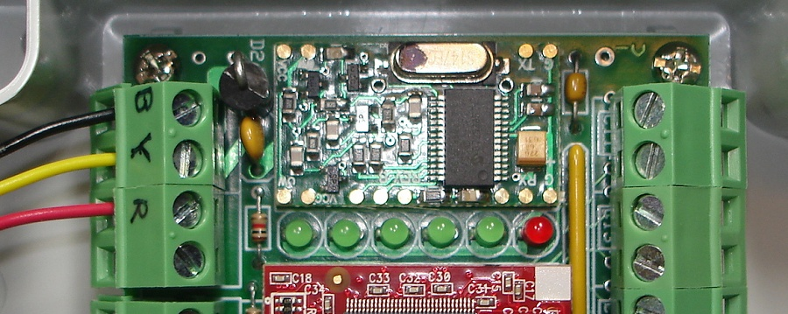
Here you see the Bus cable connected to the WEL using the standard color code.

To attach a temperature sensor, you just need to wire it to the bus at the desired location. I like to use an attachment device called a Tap-Splice. This gadget lets me crimp the sensor wires to the bus without any cutting, stripping or soldering. A Tap-Splice is clipped onto one bus wire, and the corresponding Sensor wire is inserted into the splice. The assembly is then squeezed using a large pair of pliers and the connection is made. The operation is repeated for the other wire.

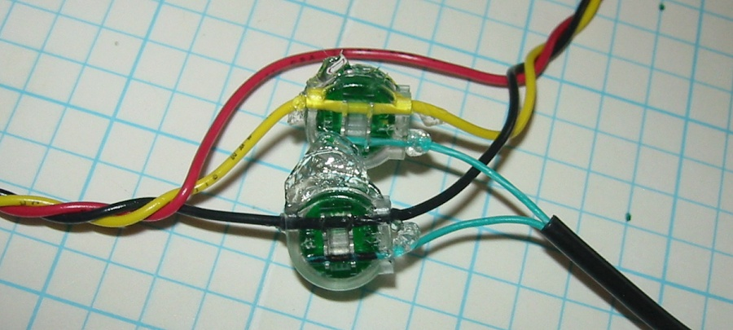
Here is a picture of a finished splice pair. The bus is running along the top of the image, and the attached sensor wires are leaving at the lower right. Notice that nothing is happening to the red wire, this is because a temperature sensor can obtain its own power from the signal bus. Each of my temperature sensors come with two Tap Splices like the ones the phone company uses for its wires.

In some situations, it’s just not convenient to have one single long bus for all the sensors. In these cases, one incoming pair might need to branch out to several sensors throughout the house (eg: at thermostat locations). Here, the various pairs are connected in “parallel” to form a “Star” network. You should attempt to limit the number of stars in your system by deciding on a central hub location and only fanning out from there.

Technical note: If you don’t want to use my sensors, you can “roll your own” using raw temperature sensors from Maxim/Dallas. Currently the WEL supports 5 different temperature sensor types. These are the older DS1820 and the newer DS18S20, DS18S20-PAR, DS18B20 and DS18B20-PAR precision temperature sensor families.

The most minimal configuration for a 1-Wire device is the “parasitic power” mode, where the device “steals” power from the data line. In this mode, the device’s VDD pin must be tied to the GND line for noise immunity. Special versions on the DS18S20 and DS18B20 devices are sold where this connection is made inside the device, thus eliminating any need for external wiring. The “–PAR” suffix is added to the part number to indicate this feature.

Here are some sample device pin-outs.
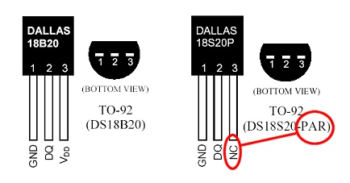

3.2 Current Switch

The Current Switch (CS) from CR Magnetics is another popular sensor for the WEL.

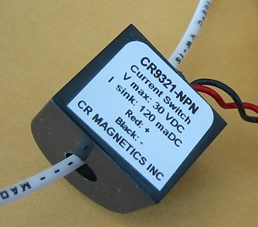
As it’s name implies, the CS is a switch that turns on when it senses current. This is a great way to detect when a device like a pump or heater element is on.

The beauty of this kind of sensor is that there is no electrical connection with the actual device being monitored, so it’s very safe. One of the power conductors of the device being monitored is passed through the hole in the CS. When more than 350ma of AC current is detected in this wire, the CS closes an optical output, which can be detected any of the 8 run-monitor inputs on the WEL.

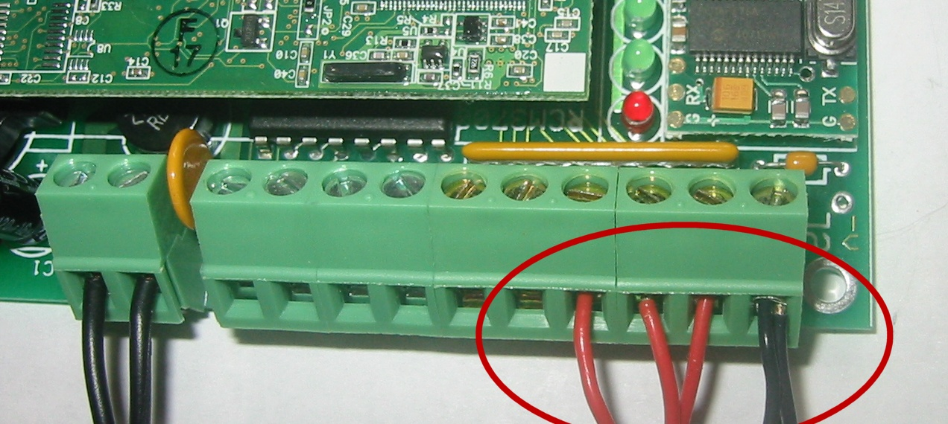
Each CS has two output wires. The black (-) wire is a common ground that is connected to either of the run-monitor COM inputs on either end of the terminal strip on the WEL. The red wire (+) is the actual signal wire, and each of these is connected to a sepparate run monitor input (1-8).

This photo shows 3 CS’s connected to the WEL as Run inputs 6,7 & 8.

If it’s not convenient to wire a CS directly to the WEL, or if you need to monitor more than 8 devices, I have developed a 1-wire interface for the Current Switch. This interface is wired to the CS, and provides the standard Black/Yellow wire pair that can then be connected anywhere on the 1-wire bus. This configuration can provide the ultimate in wiring convenience and flexibility. I call this my “1-wire Current Switch” (p/n WEL-CS)

3.3 Power (Watt) meters

The WEL has four inputs that can count pulses indicating power consumption.

Although the WEL can work with most pulse-output meters, only one brand provides the high frequency outputs that enable me to calculate an accurate instantaneous “load”. These units come from Continental Control Systems (www.CControlSys.com) and they are called Pulse-Output WattNodes.

Note: The WEL requires a high frequency output WattNode (model WNB-3Y-208-P-300Hz ) The –300Hz suffix is essential to get the high-frequency version of the unit. Without this, you will not be able to accurately measure load in watts.

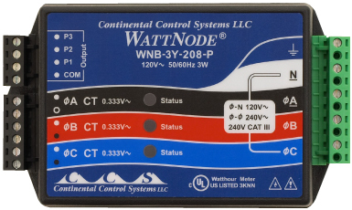

Like the current switches, the WattNode also has optically isolated outputs that can be wired directly to the WEL’s inputs. The (COM) output is wired to the common GND input on the WEL and the (P) outputs are wired to one of the PULSE input terminals on the WEL (J5). The WNB is able to measure power flow in two directions, so it’s an ideal meter for use on a Net Metered PV or Wind powered home. In this situation, the meter generates two separate pulse streams. Output P1 indicates the conventional demand load, and sends contact closures when the net flow is into the home. Output P2 indicates the excess home-generated power (PV or wind), and it sends contact closures when the net flow is into the grid. Both of these outputs are wired to the WEL, which can then display them individually, or subtract P2 from P1 to form a single +/- Net load.

The WEL has four PULSE inputs, but they are not identical. Pulse1 and Pulse2 are software counters tied to interrupts. Pulse 3 and Pulse 4 are hardware counters tied to a DS2423 dual counter chip. This is the same chip that can be used externally, attached to the 1-wire bus.

The Pulse1 and Pulse2 counters have the advantage of providing 3 distinct “devices” for Pulse rate, Daily Pulse Count and Monthly Pulse count. Each device may be scaled differently. This “may” be an advantage on different types of sensors (like flow meters or event counters). These software pulse counters also have a frequency limitation of 200Hz. You need to “enable” these counters in the System Configuration page of the WEL’s setup.

The Pulse3 and Pulse4 counters appear automatically on the Device list with Device Types of 29 and 6 respectively. These counters each consume a single Device, but Pulse rate, Daily Pulse Count and Monthly Pulse count can be easily obtained just by setting the Accumulation to “b” (See section 5.4 below). These two counters are best suited to power measurement, so they should be used first when connecting wattmeter pulse outputs to the WEL. Their frequency range is well over 1 KHz.

4.0 Getting Started

The easiest way to get started is to connect the WEL to an active Local Area Network, and apply power. You can do this by plugging the WEL into a hub or router in your home or office, and then connecting a WEL power supply.

Note: It may be possible to plug the WEL directly into your computer’s network card, but you will need a special “Crossover” cable to do this. You’ll also need your PC set up to generate an IP address for the WEL via DHCP.

4.1 Powering up

When power is applied, the WEL will boot up and load it’s operating program from FLASH memory. The 6 status LEDs give a very characteristic “ramp” display to signal the start of booting. All the LEDs light up in sequence, starting with the first green LED and working over to the RED led. This takes about a second. All the green LEDs then go off, leaving the red LED lit for about ten seconds while the boot program is decompressed. At the end of boot loading, the red LED will go off.

At this point the WEL is running, and will begin bus scanning. The Green LED near the Network Connector should go on, and stay on. This indicates that the WEL has successfully activated the TCPIP network. (You remembered to plug the cable in, right?)
To view and update the internal workings of the WEL, you must now configure a PC on the same LAN to be able to access the WEL’s local web server.

4.2 Locating the WEL’s IP Address.

The WEL is an Internet appliance. To communicate with other devices it needs an Internet Protocol Address (or IP Address). You need to know the WEL’s IP address so that you can configure it using your PC’s Internet browser.

IP Addresses are represented by a series of 4 numbers separated by periods. Each number is between 0 and 255. The WEL’s favorite IP Address is 192.168.1.50 . This address can operate with most broadband routers, but it’s not foolproof.

Devices like the WEL, can be given a “Fixed” IP or they can obtain them “Dynamically”. If you’re a net weenie, you’ll probably want to assign your WEL a fixed IP, because you can, and it makes it easy to remember. If you’re a net novice, you’ll probably want your WEL to get it’s own IP thereby eliminating the need for you to assign one.

Unless you request a specific IP when you order your WEL, it will come set-up to obtain a dynamic IP. So, once it’s up and running it will implicitly know how to talk out on the net, but you won’t know it’s IP. You will need to search it out and determine its IP address so you can “talk” to it. You will use a program called LocateIP.exe to do this. You can download this program from the WEL Support Files page of the WEL support website:

http://www.WELServer.com/support.htm

Load the program onto your PC and run it. It will immediately search for the WEL and once it finds it, will display its network parameters, including its IP address. See below.

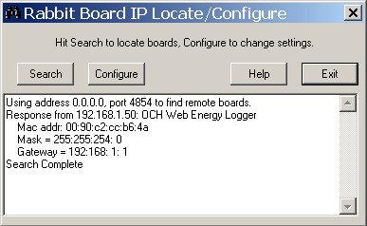

In the example, you can see that the program got a “Response from 192.168.1.50”. This is the WEL’s IP address. You’ll also not that the Gateway address is 192.168.1.1, this is typical for many network routers (like Linksys). If need be, these addresses can be changed by clicking the “Configure” button and entering the desired addresses.

If you run LocateIP and it doesn’t find your WEL, it’s probably because your PC’s firewall is preventing the WEL’s response from getting back to your PC. Try turning off your Firewall temporarily. Then turn it back on again once you have the WEL’s IP. Also try resetting the WEL to let it request an IP address again.

4.3 Using your browser to configure the WEL.

Once you know your WEL’s IP Address, you can use any Web Browser to configure it.

Start your Web Browser on the same computer that you ran the LocateIP program on. Enter the WEL’s IP address in the location that you would normally type a Web Page’s name. At the end of the IP, enter the WEL’s port number as “:5150” (colon followed by the number 5051). In this example, the address would be entered as: http://192.168.1.50:5150

Note that the address starts with “http://” and ends with “:5150”
This connection is not being made to the standard Port 80, it is using Port 5150 to enable remote access via a network router.

The Web browser should now display the WEL’s Home page, shown below.

All WEL pages have a graphic button in the top left corner that can be used to return to the main home page. In addition, at the top of all pages are simple hyperlinks to the four most commonly used pages.

The WEL’s software version and network information are the first things displayed on the home page. If your WEL shows a software version less than 2.13, then you need to use a previous version of this User Manual. Many of the screens changed when the software moved from 2.12 to 2.13.

Verify that the Network mask and Gateway address will permit the WEL to access your broadband Internet connection via your router or shared PC.
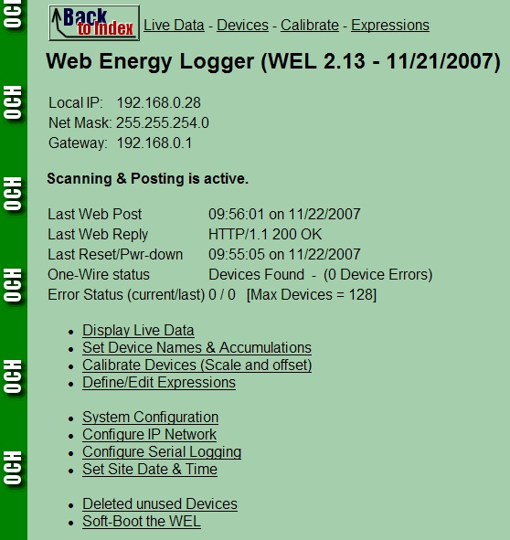

Below the network information is Web Posting and Bus Scanning status information. Scanning and Posting must be shown as “active” for the WEL to read the 1-wire bus and post data to the central server. The ONLY time scanning is disabled is when you (the user) disable it in order to delete some unwanted devices. If scanning has been disabled, there will be a red warning, and a button that can be used to re-enable it.

The snapshot above shows a typical set of status information. The last Web post shows a 200 OK message, and the 1-Wire status is “Devices Found”. Unlike the prior WEL3.2 hardware, the WEL 3.3 hardware has a dual counter chip on the board itself, so there should ALWAYS be a device found on the 1-wire bus.

The Error Status field will display the current and previous error code. A code of 0 means that there is no error present. See section 2.7 for a full list of error codes. The last item on the Error Status line is an indication of the maximum number of devices (or device slots) that this WEL supports. Prior to Software version 2.13, the WEL only supported 100 Devices. This has now been expanded to 128 devices. This increased device capability does not mean that the WEL can now support 128 physical 1-Wire devices. It was added to support additional expressions, which also take up a device slot.

Some configuration screens have been changed to support this increased device number. This entailed splitting the device list into several sections to permit smaller groups of devices to be updated at once.

The remainder of the screen is links to specialized configuration pages. The links start with the most commonly used pages, and progress down to pages that are only used infrequently. These pages are described in detail in section 5.

5.0 WEL Configuration pages

Section 4.3 introduced the WEL’s home page. Access this page by entering the WEL’s URL on you home web browser. A sample URL might be: http://192.168.1.50:5150

At the bottom of this page are a series of hyper-links to specialized configuration pages. Each of these pages is described below. Each sub-section’s title is the same as the text for the link.

5.1 Display Live Data

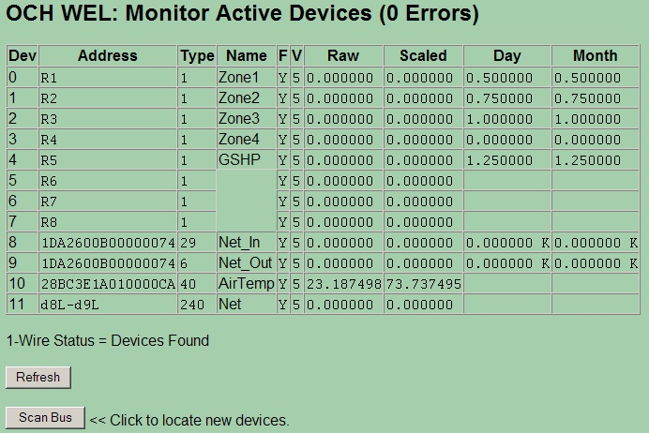

This page is used to show the live and accumulated values for ALL of the WEL’s devices, as well as internal device information. Each row in the table is a “Device Slot”. Each slot has several attributes as indicated by the column headers. These are defined as follows:

Dev: Device ID. As each device is added to the system, it is allocated a sequential device Id. Once assigned, a particular device will keep its ID (even when powered of) unless the user manually deletes the device from the system (see section 5.x for details of deleting devices)

Address: A Device Address will either be the 64bit unique number assigned to a 1-wire device, or it will be a special code assigned to a “virtual device” by the WEL program itself. In the example above, addresses like “R1”, “R2” and “d3L-d9L” are virtual devices whereas the 16 character Hexadecimal numbers are actual 1-Wire devices. If two or more device slots have the same address, it means that there is more than one sensor in a physical package. Each sensor has it’s own slot, but they share a 1-wire address.

Type: There are many types of Device Slots. This number is a code to indicate the slot’s function. Appendix A has a list of different device types.

Name: For a device value to be posted to the Web, it must be assigned a logical name. This name can be up to 16 characters, and should indicate the function of that device. Eg: Zone1 for a zone pump run sensor, or T_Bed for a bedroom temperature sensor. Names ARE case sensitive so come up with a system, and make sure you enter them the same way on the various configuration screens.

F: Found: When the WEL powers up, or is reset, or the user requests a “Bus Scan” the software scans the 1-Wire bus looking for all connected 1-wire devices. Any devices that it finds are marked as “Found” and a “Y” is placed in the found column. If a 1-wire device was previously found, but is no longer present it is marked as Not Found with a “N” character. When new 1-wire sensors are added to the bus, you must trigger a “Bus Scan” to have it appear on the sensor list as Found. Only devices marked as “Found” are then polled and reported to the Web.

V: Valid: Since the WEL knows what sensors were “found” when it last scanned the bus, is expects those devices to be there each time it polls the bus for data. Whenever a device is polled, and returns good data, the “Valid” count is set to 5. So a “5” in the “V “column means that the sensor is fully functional. However, if a device does not respond, or if the returned CRC from that device is invalid its “Valid” count is decremented. This will happen each 6-second poll cycle. So a “0” in the “V” column means that 5 attempts in arrow to read that device have failed, so the device is considered “bad” and no data will be posted for it.

Raw: This is the raw (unscaled) value of the sensor. For example, this will be the temperature in degrees Celsius for the 1-wire temperature probes.

Scaled: This will be the scaled value of the sensor. Every device slot has its own scale and offset, which can be applied to the raw sensor value. For example, the scale and offset for a temperature sensor defaults to 1.8 and 32 to convert Celsius to Fahrenheit. See section 5.3 for more details on Scales and Offsets.

Day: This is the accumulated “Hours” value for this device. There will only be a number in this column if Day Accumulation is turned on (See section 5.2). Accumulation is useful for sensors like WattMeters or Run monitors. Each minute, the current scaled value of the device is multiplied by (1/60) and added to an accumulated total. This converts an on/off run monitor into run-hours, and a wattmeter device into watt-hours. It’s also possible to request an additional reduction by 1000 and a “K” after the accumulated value indicates this. Day accumulations are reset each evening at midnight.

Month: Like the accumulated Day hours, this column shows the accumulated “Hours” value for the current month. This value is reset at midnight at the end of the last day of the month.

5.2 Set Device Names and Accumulations.

This page is used to set the Name and Accumulation mode for each device slot. For explanation of the ID, Type, Address and Found columns, refer to the descriptions found in section 5.1. Each slot can be given a name of up to 16 characters. Spaces cannot be used in a name, and if they are, the system will replace them with an underscore “_” character.

Each device can also be assigned a single “accumulation” letter. This letter defines if/how hourly usage data should be generated. Notice on the page below that devices 0-4 have accumulation set to “B” so Both Daily and Monthly accumulation are enabled. However devices 8 and 9 have accumulation set to lower case ‘b’, which means they also have both accumulations enabled, but their values will be reduced by 1,000 for usability as KWH.

When posting accumulated data to the Web, the WEL adds a _D or _M suffix to the end of the base device name. In the example below, the WEL will also post a value for GSHP_D (the daily hour total) and GSHP_M (the monthly hour total).

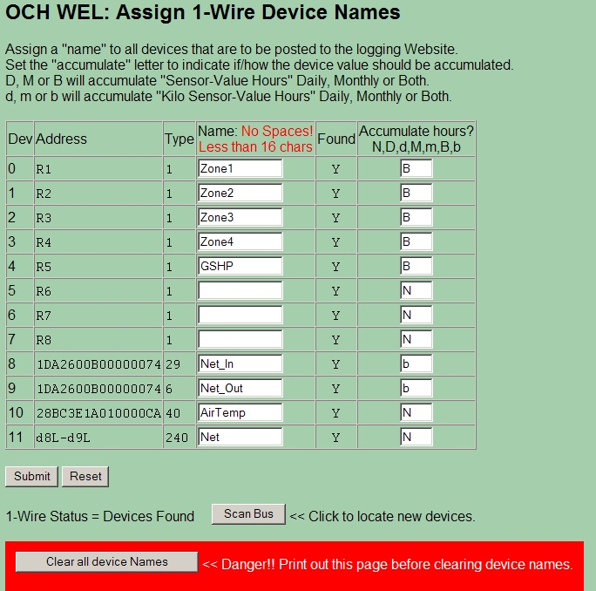

This page also has a “Scan Bus” button, which can be used to force the WEL to rescan the 1-wire bus to look for new or missing devices. When first wiring an installation, use this screen to quickly identify and name new devices as you connect them up for the first time.

The process is as follows:

1) Add a sensor to the bus. 2) Click “Scan Bus” to get the sensor’s address. 3) Enter a name for the new device that appears at the end of the list. Repeat 1-3 for all sensors.

The final button on this page is used in the UNLIKEY event that you wish to clear the WEL’s memory of all devices and force it to completely recreate the list of sensors. All the assigned names will be lost in this process so it should only be used when absolutely necessary

5.3 Calibrate Devices (Scale and Offset)

This page is used to set the scale and offset for a device in order to convert from a raw sensor value to a more desirable “real World” value. Some devices “appear” with a default scale and offset (like temperature sensors) but usually the scale defaults to 1.0 and the offset defaults to 0.0.

The scaled value is calculated as follows:

Scaled = (Raw * Scale) + Offset

Some devices “appear” with a default scale and offset (like the temperature sensor in the example below) but usually the scale defaults to 1.0 and the offset defaults to 0.0. The Web page shows the most recent raw and scaled value to help verify that the calibration is reasonable.

In some temperature sensor applications, where an accurate delta T reading is required, it may be necessary to perform an accurate calibration on the sensors. One way to do this is to log the values from the two sensors when they are attached to the same metal object. Then average the values to determine the difference between the two sensors. This difference can be added to the offset to the low sensors to bring their two values in line.

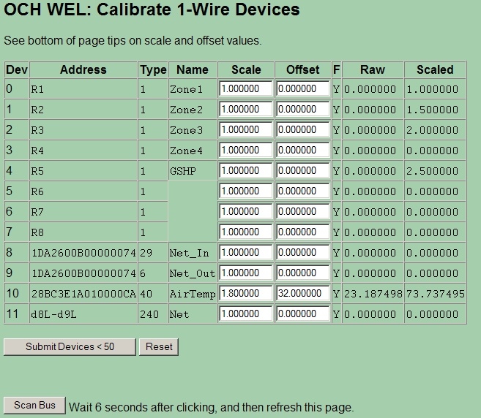

Due to WEL’s memory limitations, the calibration Web page is split in two sets of 50 devices. When a change is made, simply submit that set of values.

Note that this page also has a Scan Bus button to aid in initial system installation.

5.4 Define/Edit Expressions.

This page enables users to create special “Virtual devices” called “expressions”, which can be used to perform simple mathematical calculations on sensor data. The results of these expressions can then be posted to the Web, just like real device data.

Expressions are VERY rudimentary, and they come as two basic building blocks. One building block lets you create a Constant (number) that can be used in other expressions. The other building block lets you perform a Simple Operation on two device values. This operation could be add, subtract, multiply or divide, or it could be a Boolean and/or operation, or it could be a < > comparison. The result of the operation is saved out as the value of the “Virtual Device”. This value can also be accumulated like other devices.

Expressions are created using a two-step process. First you do an “Add New Expression” and then you “Edit” the new expression it to set its behavior. The following screen shows the process of editing an expression. The Web form presents two gray areas.

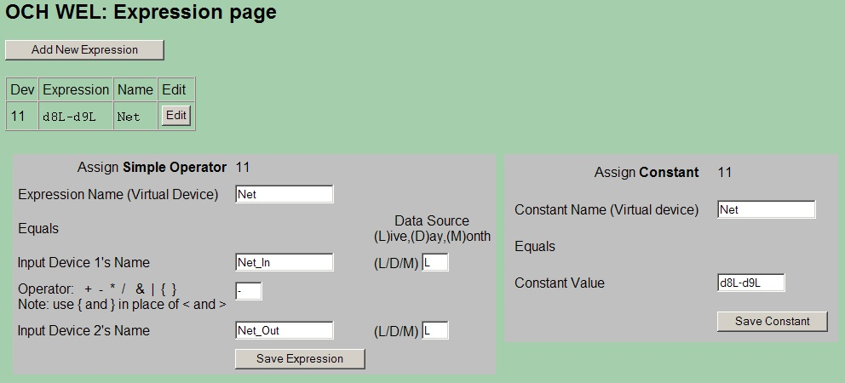

You choose “simple operator”, or “constant” by filling in the required fields and then clicking the appropriate Save button. In this example the expression’s name is “Net”, and the goal is for the expression to combine two power readings.

To define a simple operator use the area on the left. The first text box is the Expression Name. This name must be unique, and it will appear on the Device List. The next text box is the name of the first term of the expression (in this case Net_In). This name must be the name of an existing device. In addition, there is also a box to indicate if you want to use the Live value of this input, or either of the Accumulated values. Next comes the operator to be used for this expression. Enter one of the characters shown to the left of the box. Finally the name of the second term of the expression is entered (Net_Out), along with it’s source letter (L).

So reading this expression from top to bottom…

Net = Net_In (Live) – Net_Out (live)

After entering the fields, or making changes, the Save Expression button must be clicked.

To create a device, which holds a constant number for calculation purposes, the number would be entered in the “Constant Value” box on the right hand gray area, and Save Constant would be clicked.

Any number of expressions may be created, up to the maximum limit of 128 devices. Multiple simple operators may be combined in series to form more complex expressions, and each expression may utilize the device’s Scale and Offset calibration values. The key issue to remember is that each expression must have a different name. Once an expression is saved, the “Address” field for that device is used to display a mnemonic for the expression. This acts as a “reminder” to you for what that expression does. The mnemonic indicates the IDs for the two input devices as well as the operator: eg: d8L–d9L. If an invalid device name was entered, the Device ID will be shown as 255.

5.5 System Configuration

The System Configuration page is used to set general properties for this WEL installation.

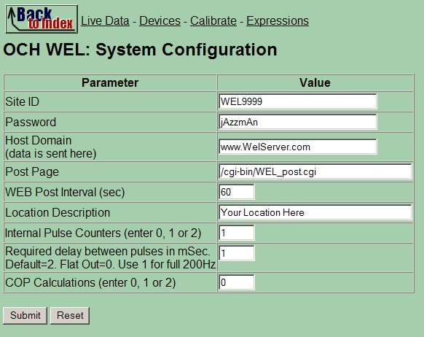

Each WEL has its own unique Site ID and Password that is used for posting data. These values will be set on your WEL before it’s shipped. The Host Domain and Post page are also set before shipping, but these can be changed if you want the WEL to post you your own Web Page.

The last three fields are for defining some additional Virtual Devices.

Internal Pulse counters are used for Pulse1 and Pulse2 inputs, and these are described in section 3.3. If these counters are required, set the desired quantity in this box and the WEL will add them to your Device List. Each counter causes three devices to be created. These have addresses of M?Load, M?Day and M?Month (where ? is either 1 or 2) M?Load will indicate the number of pulses per minute, M?Day will accumulate pulses for the day, and M2Month will accumulate pulse for the month. These devices will be configured with default calibration values for the WNB-3Y-208-P-300Hz wattmeter using 100A CTs (indicating load in Watts and Accumulated power in KWH). You can change the scale to calculate any other unit based on a units per pulse conversion.

On these two pulse inputs, you can configure a minimum “required” delay between pulses. On high-speed digital inputs, this delay should be kept low (0-2), however if a slower mechanical device is being monitored (eg a 1 Pulse/Gal flow meter) then a substantial pulse delay can be entered (50-200) to eliminate any mechanical switch bounce.

COP calculations were added before expressions were available. COPs are now unnecessary, and this field is just included here for existing users to disable their COPs once they have converted them over to use expressions.

5.6 Configure IP Addresses

This page enables the user to change the current IP addresses for the WEL. This page can be used as an alternative to the LocateIP program for making these changes. The factory default setting for the WEL is to have an IP address of 0.0.0.0, which forces it to request a dynamic IP via DHCP. If you want the WEL to use a Fixed IP, set it here. Remember that if you change the IP address, you will need to enter that new IP into your browser once you hit Submit. To get access to the Internet, you also need to set the Gateway IP. This could be your Cable modem, Network Router or Internet Sharing PC. The default for this is 192.168.1.1, which is a common router setting. Finally you may need to enter the IP of your ISP’s Domain Name Server (DNS).

If you change any of these settings and hit submit, the WEL will reset itself to load the new settings.

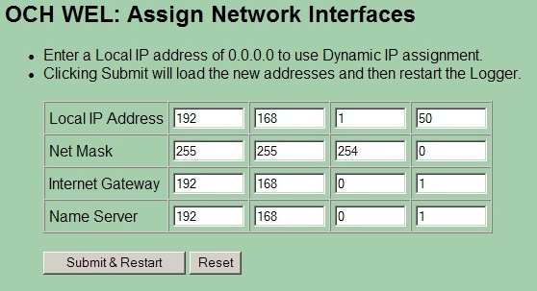

5.7 Configure Serial Logging.

The WEL is able to transmit an RS-232 serial string with select device data. This page configures the string format and the data content.

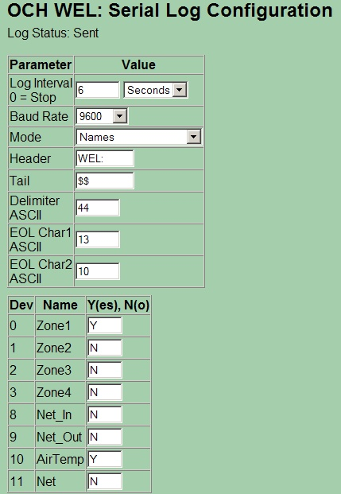

The following Serial String attributes can be set on this page.

Log Interval: The interval between serial packets can be set for short or extremely long intervals. (Seconds to days). If the period is set to 0, then serial logging is disabled.

Baud Rate: Baud rates from 1200 to 115200 are available.

Mode: Four transmission modes are available. These are a combination of two options: “Include Date/time” and “Include Names”. Using the settings shown on the example image above, samples of the four formats are shown below.

Date/Time Names (The most verbose format)

WEL:Date=11/12/2007,Time=09:53:58,Zone1=0.0,Zone1_D=0.0,Zone1_M=0.5,AirTemp=68.9$$

Date/Time No Names

WEL:11/12/2007,09:54:29,0.0,0.0,0.5,68.9$$

Names

WEL:Zone1=0.0,Zone1_D=0.0,Zone1_M=0.5,AirTemp=68.8$$

No Names (The most brief format)

WEL:0.0,0.0,0.5,68.9$$

Header: Any 7 printable characters may be added at the start of every transmission.

Tail: Any 7 printable characters may be added at the end of every transmission. This will be before any final EOL characters.

Delimiter ASCII: This is the ASCII value (decimal) for the character you want to use to separate the device values. Suggestions are 44 (comma) or 9 (tab)

EOL Char1 ASCII: This is the ASCII value (decimal) for the first End Of Line character to be put at the end of the transmission. A typical value would be 13 (CR)

EOL Char2 ASCII: This is the ASCII value (decimal) for the second End Of Line character to be put at the end of the transmission. A typical value would be 10 (LF)

All the available devices are then listed on the page. Place a “Y” in the box next to a device if you want it included in the serial stream. Al devices (named and un-named) are shown in the list because there is no requirement for a device to have a name in the serial log. If a device has accumulated values associated with it, these will also be output.

5.8 Set Date and Time

The WEL has a real time clock that is used to timestamp data posted to the web, and through the serial port. This clock should be set when you receive the WEK, but it may be set to the wrong time zone. This page can be used to set the date and time. Simply enter the appropriate information and click Submit.

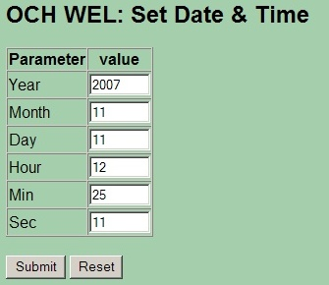

5.9 Delete unused devices

Once you’ve been using your WEL for a while, or after doing some experimentation with expressions or different sensors, you may have some devices on the main Device List that you no longer need. But the WEL is designed to “never forget” a device, so you need to go out of your way to force the WEL to remove these devices.

Since the system is constantly referring to the Device List for polling and posting data, you first need to disable scanning. The system knows this, and when you first go to this page, it will present the following screen.

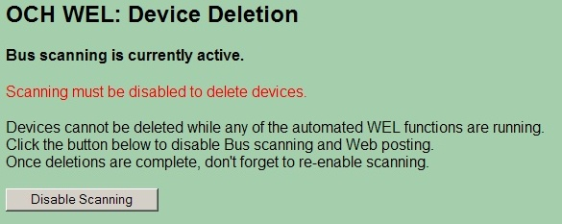

If you are ready to delete devices, click the Disable Scanning button. The WEL will be immediately put in idle mode and shortly thereafter; the Bus Poll LED on the WEL will start blinking rapidly. This is a visual reminder that you are no longer posting data, and that you should re-enable scanning as quickly as possible.

Now the WEL will display a new screen that has an Enable Scan button, as well as Delete buttons for each of the available devices. Physical sensors that contain more than one device must be deleted as a group, so next to each Delete button is text indicating how many device slots that button will delete.

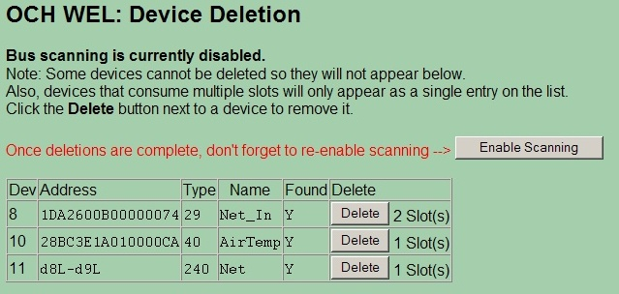

Each time you click a Delete button, the screen will refresh to show the new delete list.

WARNING: Make sure you Enable Scanning once you are done deleting devices.

Note: There is no point in deleting a 1-wire device that is still present on the bus, since the next time the WEL is reset, it will just add it back to the list.

5.10 Soft Boot the WEL

If you ever need to reset the WEL, but don’t have access to the physical hardware (during a remote connection) then you can use this page to force a software re-boot. This will have the same effect as a hardware reset. It will cause the WEL to reload its program from flash, and start with a clean slate.

Since this is not something you want to happen by accident, the page requires a second button click to confirm the reboot.

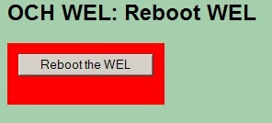

Once a reboot has been requested, the program won’t restart for 10-12 seconds until the boot sequence is complete. At that time you may need to use LocateIP.exe again if the WEL is assigned a new IP address.

6.0 Owner Website Setup

It’s more fun to set up your Web Logging page when you have real data coming from your WEL, but if you don’t have your WEL yet, you can still get ready by defining your expected data and desired display.

In section 5, we were dealing with web pages that exist on the WEL board itself. However, all of the Web Pages described in this section relate to the Online Owner Setup pages that exist out on the World Wide Web. This is where you WEL posts its data, and this is where the cool graphics are generated and where the sensor data logs reside.

6.1 Getting access

There are three main Owner Setup activities, and they are all managed from your password protected Owner Setup page, which is located at:

www.WELServer.com.

Once at this website, you can click any of the protected links in the Owner Setup section of the left-hand menu. The best place to start is Setup Overview.

To access your setup page, you will be asked for a User Name and Password. You must enter your WEL’s Site ID and password. These are the same items that appear on your WEL’s Configure Site page. You will also receive these from Phil when he ships your WEL unit. If you don’t have this information, call or email Phil.
Phone: (301) 387-2331, Phil.Malone@Mr-Phil.com

Once you reach the Owner Setup page, add it to your browser Favorites. You’ll be back here often.

The Setup Overview page provides a quick snapshot of your current configuration. It shows the last post that was received from your WEL, how you want your data logged, what you want displayed on your “System Image” and what graphs you want to be generated. It also contains links to other pages where you actually edit these various settings. A sample Owner Setup page is shown below:

Notice that each section has a link called “Edit”. Click this link to change the information in the adjacent table. You will be taken to a new page with one or more text entry fields. The sub-menu links in the left hand sidebar take you to these same pages.

Note: This next sentence is probably totally wasted on people just like me, but I’ll try it anyway.

If you have a question about what to enter on any particular page, scroll down and READ the Tips at the bottom of the page. I hate typing, so if I’ve gone to the trouble of including a tip, then there must be a really good reason. Trust me… I can read your mind. Plus if I need to add more help info. I’ll do it there, rather than in this document. So don’t say I didn’t tell you ☺

6.2 Local and remote IPs.

One cool thing on the Setup page is a display of the WEL’s local and Remote IP addresses. Click on the local IP to access the WEL from within its Local Area Network. Click on the Remote IP to access the WEL from the Internet. Remote access only works if port 5150 has been routed through to the WEL via the broadband router at your location. This is a security precaution.

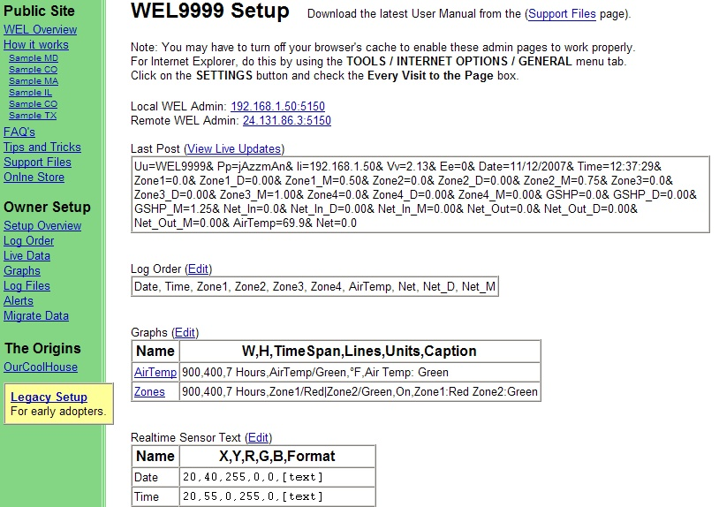

6.3 Viewing the Last Post

The first box at the top of the screen shows the last data that was posted by the WEL. This is useful during debugging to ensure that you are getting data (check the date & time sections) and to verify the names of posted sensors.

The View Live Updates link will take you to a page that shows all your generated images. These will automatically update each time you get a WEL data post. This is another good page to bookmark as it’s not password protected so you can send the URL to your friends, or just use it to check your WEL.

6.4 Setting the LogOrder

The first thing you need to do is define which sensors will be logged, and in what order.

This is a good time to sit down and give names to all the sensors you intend to have attached to the WEL. Start a document or spreadsheet to keep track of the names and functions. These names MUST match the names you define on the WEL, but don’t worry if you haven’t installed them yet. Just give them a name and add them to the LogOrder.

Each time the WEL posts data, the values of the sensors in the LogOrder are added to your downloadable Log File. They are stored in tabbed columns that can be imported into Excel. Choose a log order that will make it easy to view and analyze your data. Missing sensors are logged as Question marks, to keep the columns intact.

Click the Edit link above the LogOrder Box to make changes to the Log Order..

Note: The LogOrder Edit page also contains a link to your actual Log files, so go there to download them. Here is a sample LogOrder screen:

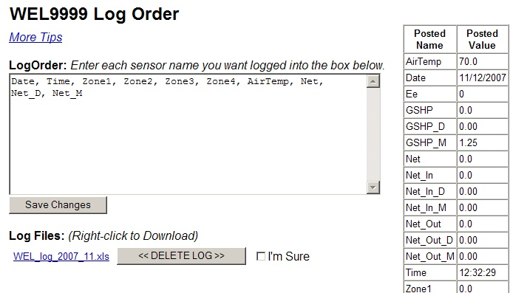

6.5 Defining Graphs (or Charts)

The second best thing you can do with WEL data is build graphs. You can have up to 12 graphs, each with up to 8 sensors on them. Graphs are great for plotting Zone Air or Water temperatures or GSHP power usage or whatever. If you really want to see how something is working… then graph it.

Graphs can show short or long trends, from hours to weeks. You get to set the size and duration of the chart just by entering some simple information. Click on the Edit link above the Graphs box to start defining graphs. Read the instructions on that page for detailed information on how to define graphs. Here is a sample Graphs Edit page.

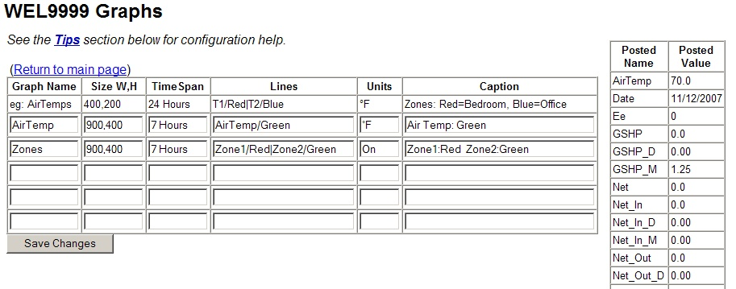

6.6 Defining your Live System Diagram.

OK, this is the BEST thing you can do with WEL data. This is where you get to pull all the WEL data together on one cool system diagram that automatically gets updated with sensor values.

It all starts with you creating a “Template” image. Take your favorite image creation program (paintshop, photoshop, visio, whatever) and draw a diagram of the system you are monitoring. Don’t go crazy right off the bat making it too big, or too complicated. Start out with a size that’s easily viewable on most computers. I’d recommend making it less than 800 pixels wide and less than 600 pixels tall. In fact, 640x480 is a great size. Then decide how you want to depict your system so that you can easily add numeric sensor values. Here’s some example links of images WITH their sensor values:

http://www.WELServer.com/WEL1000/system.png << 640 x 480

http://www.ourcoolhouse.com/WEL/WEL0003/system.png << 815 x 665

Your goal is to create an image without the sensor values, upload it to your Owner Setup page, and then tell the page where you want the sensor values put. You’ll need to create an image using the .PNG format (like .gif) and then upload it using the “Realtime System Image” Upload button on the Setup page. The other factor is that it’s REALLY important that the final image has a palette of only 255 colors. Reduce the .png down to 255 Web Safe colors.

NOTE: I’ve found that if your image has more than 256 colors, then the live text does not get drawn in the correct color. So if your text is a funny color, it’s probably because your image is not using a 256-color (or less) pallet.

Once you’ve uploaded the image, it will appear at the bottom of the Setup Overview page in its “raw” form. The annotated image wil appear after the war one, once your WEL has posted new data.

After uploading the image, use the “Realtime Sensor Text” Edit link to start adding values to the image. Any sensor value being posted by your WEL can be added to the image, including the post date and time.

Data is added to the image automatically by the WELServer website, so you need to tell the system what device names to add, what location and color to use and how to format the text. This is done using a simple web form, where each item is defined by one row of a table on the form. See the sample edit page below.

Date and Time are always the best to start with, and the default Owner Setup page has these already. Just change the position to suite your graphic. Remember, the System diagram is only updated one a minute, so allow enough time between changes to see your results. Watch the "time" on your image change to tell if the image should have been updated.

Note: The Tips on this edit page are EXTREMELY important, so make sure you read them to get the most out of your image. Here is a sample Live Image Text Edit page.

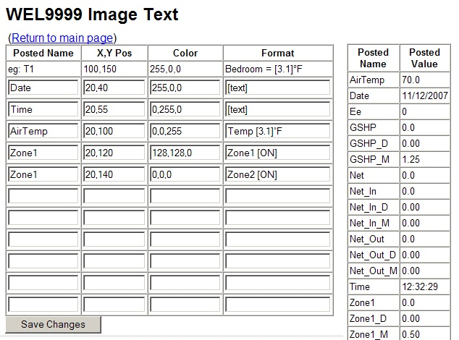

6.7 Watching your data

Remember that there is a public web page that includes your system image and all your charts. Its address is based on your Site ID. The URL format is:

http://www.WELServer.com/WELXXXX

Where XXXX is your Site ID. While making changes to your setup, you may want to keep this page open in a new window to see the results of your settings. Send this URL to your friends and colleagues to show off your data.

Since this is a public page, images from this page can also be included in your own custom website. Just copy the URL from the name above an image and use it to define the image location in your own web design tool.

Appendix A: Device Type codes

When a physical device is added to the 1-wire bus, it will show up as one or more “logical” devices on the sensor list. Each device has an “address” and “type”. The following list shows the meaning of each device type:

Type | Function | Additional channels
01 | Local Run monitor input | 0
02 | Local Pulse counter input | 0
03 | COP calculation | 0
06 | DS2423 Dual counter (Channel B) | 0
14 | Additional Unfiltered channel | 0
15 | Additional Filtered channel | 0
16 | DS18S20 Temperature Sensor | 0
18 | DS2406 Digital Input | 0
29 | DS2423 Dual counter (Channel A) | 0
32 | DS2450 Quad A-D Converter | 3
38 | DS2438 Battery Monitor (Humidity/Solar) | 1
40 | DS18B20 Temperature Sensor | 0
41 | DS2408 8 Channel Digital I/O | 7
240 | Expression | 0

Appendix B: Compatible Third Party 1-Wire devices

The following devices are compatible with the WEL 1-wire and the WEL software.

1) Devices based on Maxim’s DS1820, DS18S20 (PAR) or DS18B20 (PAR) temperature sensors.

eg: Ruggedized temperature probe from www.embeddeddatasystems.com

2) Devices based on Maxim’s DS2438 Battery monitor

eg: Hobby-Boards.com humidity/solar sensor
(http://www.hobby-boards.com/catalog/product_info.php?products_id=57)

Note: this sensor will show up as two devices: The first device is type 38 and corresponds to the measured Voltage. The second device is type 15 and is the measured current.

3) Devices based on Maxim’s DS2423 Dual counter

eg: Hobby-Boards.com Dual Counter Board
(http://www.hobby-boards.com/catalog/product_info.php?products_id=42)

Note: This sensor will show up as two devices. Counters A and B will show up as types 29 & 6 respectively.

4) Digital Input devices based on Maxim’s DS2406 I/O port

Note: The WEL only interrogates the A channel of this device. The optional B channel is ignored.

Appendix C: Temperature Measurement tips

With economical temperature sensors like the ones used by the WEL, it is difficult to obtain highly accurate temperature readings. However, if due care is taken when attaching sensors, it’s possible to get very respectable readings.

The “Encapsulated” sensors sold by OurCoolHouse are designed to be robust and reliable. Since the sensors have been sealed against moisture intrusion, it’s impossible to place the sensor chip in direct contact with the surface to be measured, but an opening on one side has been provided to permit better heat transfer.

The first step in getting a good reading is to provide a SOLID thermal path from the item to the sensor. In many cases the item to be measured is a copper water pipe. In this situation it’s desirable to locate the sensor as close to the heat source as possible. For example, if you were measuring the output temperature of a solar collector, you’d want the sensor right at the output of the panel.

Ideally you want the sensor located on a section of pipe that has turbulent flow. The best place is just AFTER a bend in the pipe. You want to ensure good thermal conduction with the pipe, so you should clean off any surface corrosion or “gunk”.

There are several options for producing a solid thermal contact. A simple way is to use a hose clamp to strap the sensor to the pipe. If you added some heat sink compound under the sensor it would be even better. Cable ties would also work, but it’s hard to get them really tight, so the contact might not be as effective. Another option would be to use thermal epoxy to “glue” the sensor to the pipe. Try to get as much of the sensor in contact with the pipe as possible.

Once the sensor is attached, it’s a good idea to wrap several turns of the sensor wire around the pipe before connecting it to the bus. This insures that the sensor wire is at about the same temperature as the pipe, so the wire doesn’t pull heat away form the sensor and affect the readings.

Finally, the whole assembly should be insulated from the ambient air with some good pipe insulation.

Given these precautions and typical water temperate rate changes, the readings from your sensors should all be consistent within a degree or so.

